**Tasks:**

**Q.Calculator from HTML,CSS,JS**

* **Index.html:**

|  |
| --- |
| **<!DOCTYPE html>**  **<html lang="en">**  **<head>**  **<meta charset="UTF-8">**  **<meta name="viewport" content="width=device-width, initial-scale=1.0">**  **<title>Simple Calculator</title>**  **<link rel="stylesheet" href="styles.css">**  **</head>**  **<body>**  **<div class="calculator">**  **<input type="text" id="result" disabled>**  **<div class="calculator-buttons">**  **<button class="number" onclick="appendValue('7')">7</button>**  **<button class="number" onclick="appendValue('8')">8</button>**  **<button class="number" onclick="appendValue('9')">9</button>**  **<button class="operation" onclick="appendValue('/')">/</button>**  **<button class="number" onclick="appendValue('4')">4</button>**  **<button class="number" onclick="appendValue('5')">5</button>**  **<button class="number" onclick="appendValue('6')">6</button>**  **<button class="operation" onclick="appendValue('*')">*</button>**  **<button class="number" onclick="appendValue('1')">1</button>**  **<button class="number" onclick="appendValue('2')">2</button>**  **<button class="number" onclick="appendValue('3')">3</button>**  **<button class="operation" onclick="appendValue('-')">-</button>**  **<button class="number" onclick="appendValue('0')">0</button>**  **<button class="number" onclick="appendValue('.')">.</button>**  **<button class="clear" onclick="clearResult()">C</button>**  **<button class="operation" onclick="appendValue('+')">+</button>**  **<button class="equal" onclick="calculateResult()">=</button>**  **</div>**  **</div>**  **<script src="scripts.js"></script>**  **</body>**  **</html>** |

* **Styles.css**

|  |
| --- |
| **body {**  **font-family: Arial, sans-serif;**  **display: flex;**  **justify-content: center;**  **align-items: center;**  **height: 100vh;**  **margin: 0;**  **background-color: #f3f3f3; }**  **.calculator {**  **background: #fff;**  **padding: 20px;**  **border-radius: 10px;**  **box-shadow: 0 4px 8px rgba(0, 0, 0, 0.1);**  **width: 90%;**  **max-width: 320px; }**  **.calculator-buttons {**  **display: grid;**  **grid-template-columns: repeat(4, 1fr);**  **gap: 10px; }**  **.calculator input[type="text"] {**  **width: 100%;**  **height: 50px;**  **margin-bottom: 15px;**  **text-align: right;**  **padding: 10px;**  **font-size: 1.5em;**  **border: 1px solid #ddd;**  **border-radius: 5px;**  **box-sizing: border-box; }**  **.calculator button {**  **height: 60px;**  **font-size: 1.2em;**  **border: none;**  **border-radius: 5px;**  **cursor: pointer; }**  **.calculator button.operation {**  **background-color: #ff9f43;**  **color: white; }**  **.calculator button.number {**  **background-color: #74b9ff;**  **color: white; }**  **.calculator button.clear {**  **background-color: #ff7675;**  **color: white;}**  **.calculator button.equal {**  **background-color: #55efc4;**  **color: white;**  **grid-column: span 4; }**  **.calculator button:active {**  **transform: scale(0.99);**  **transition: transform 0.1s;**  **background-color: #a2a5a4; }**  **@media (max-width: 400px) {**  **.calculator button {**  **font-size: 1em;**  **height: 50px; }**  **.calculator input[type="text"] {**  **font-size: 1.2em;**  **height: 40px; } }** |

* **Script.js:**

|  |
| --- |
| **function appendValue(value) {**  **document.getElementById('result').value += value; }**  **function clearResult() {**  **document.getElementById('result').value = ''; }**  **function calculateResult() {**  **try {**  **const result = eval(document.getElementById('result').value);**  **document.getElementById('result').value = result;**  **} catch {**  **document.getElementById('result').value = 'Error'; }**  **}**  **document.addEventListener('keydown', function(event) {**  **const key = event.key;**  **if (!isNaN(key) || ['+', '-', '*', '/', '.'].includes(key)) {**  **appendValue(key);**  **} else if (key === 'Enter') {**  **calculateResult();**  **} else if (key === 'Backspace') {**  **const current = document.getElementById('result').value;**  **document.getElementById('result').value = current.slice(0, -1);**  **} else if (key === 'Escape') {**  **clearResult();**  **} });** |

**OUTPUT:**

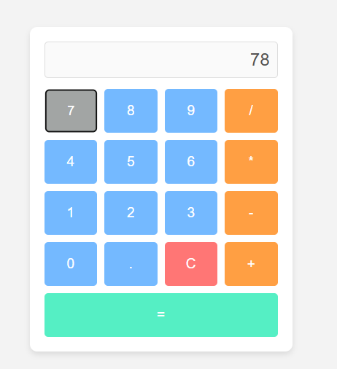**1. Add animations to buttons when they are clicked**

2. Implement keyboard support to allow users to type numbers and operations directly.

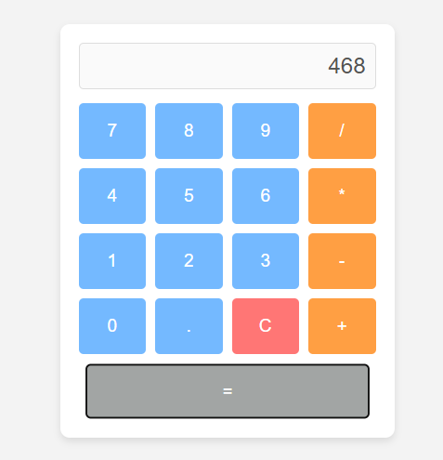

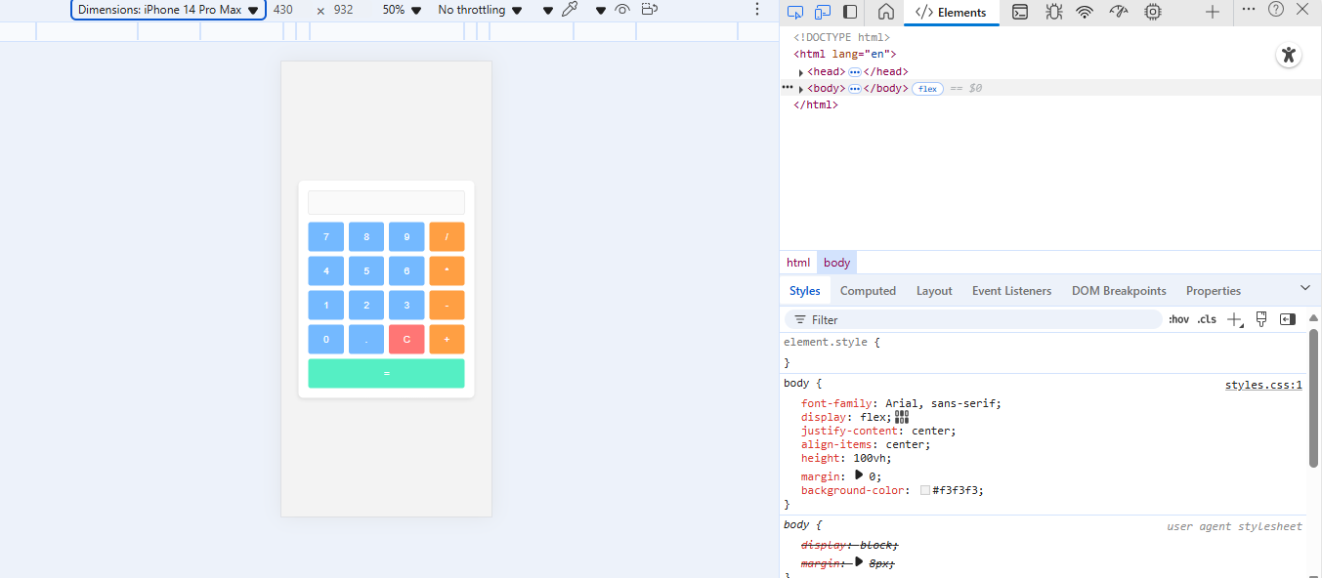3. Modify the design to make it more responsive for different screen sizes (mobile and desktop).